Bloomberg Law
and Original Jurisdiction

Successful Business Development Is All About Authenticity

Cravath and Debevoise’s former chief marketing officer, Deborah Farone, shares insights into business development from top women lawyers.

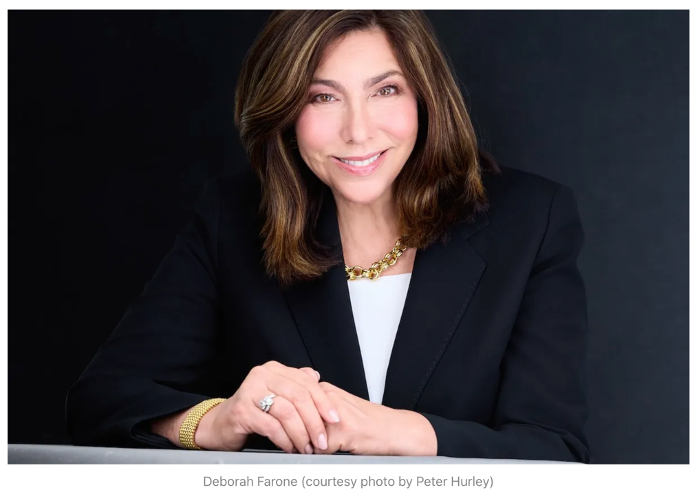
March 11, 2026
David Lat

March is Women’s History Month, and last Sunday, March 8, was International Women’s Day. It’s an opportune time to talk about the representation of women in the legal profession—specifically in Big Law.
Women represent more than 51% of associates, according to the latest data from the National Association for Law Placement, but they make up only 29% of partners and 25% of equity partners. These statistics suggest that while women have made strides forward, more progress can be made.
In the world of large law firms, partners with the most business enjoy the greatest power and highest pay. So for female lawyers to continue advancing, they must excel at business development, according to Deborah Farone—former chief marketing officer at top law firms, Cravath Swaine & Moore and Debevoise & Plimpton, and author of a new book, “Breaking Ground: How Successful Women Lawyers Build Thriving Practices.”
Last week, I interviewed Farone about business development and “Breaking Ground.” I began by asking: What inspired her to write it?
“I had been hearing for years that women at law firms felt they didn’t have enough in terms of training and role models for business development,” she said. “At the same time, I was meeting so many women who were amazing rainmakers, both in the US and abroad. I wrote this book to bridge that gap.”
To research “Breaking Ground,” Farone conducted more than 60 in-depth interviews with women from around the world who are experts in business development. She spoke with law firm chairs, rainmaking partners, business development experts, and academics from four continents—North America, Europe, Africa, and Asia. (Although Farone focused her research on women in the legal sector, she emphasized that her book can help men, as well as non-lawyers looking to get better at business development.)
What did Farone learn after this extensive research? Although her book contains plenty of practical advice, she isn’t big on tips and tricks such as “spend 10 minutes a day on networking activities.”
“Business development is all about authenticity,” Farone said. “It’s not one size fits all. Everyone has their own style. Clients can tell when what you’re doing feels right or not—and it’s incredible what happens when you’re being yourself.”
Take Annalisa Reale, a partner at Italian law firm Chiomenti Studio Legale. While she was growing up, she was a classical violinist, and she’s had a lifelong love of music. One of Reale’s most successful methods for business development is taking clients to musical performances, such as orchestral concerts and operas, followed by a nice meal. To Reale, it’s all about “sharing values and things you are truly passionate about—and that defines what you are in professional and personal terms.”
Susan Eandi, a partner at Baker McKenzie in San Francisco, enjoys taking (very early) morning walks. She mentioned this once to a client, who asked to join her, and now Eandi goes on morning walks with multiple clients and friends. Most of the time, they don’t discuss business on these walks. But when a client does develop a legal need, Eandi and her firm are top of mind.
“You’re much more likely to repeat a business-development activity if you enjoy it,” Farone said. “If you find something you like, you’ll do more of it.”
As a consultant and speaker, Farone needs to engage in business development of her own. She happens to be a coffee devotee: “I love coffee and I love talking to people, so that’s what I often do with current or prospective clients.”
As someone who enjoys coffee and conversation, this resonated with me. But what about individuals who are more introverted?
“Business development doesn’t have to be something extensive, like throwing a party or hosting a large seminar,” Farone told me. “You can start with something as simple as scheduling a phone or Zoom call to catch up with someone.”
For lawyers who don’t enjoy going to conferences or cocktail parties, LinkedIn—to which Farone devotes an entire chapter in “Breaking Ground”—is an excellent option. As Farone writes, LinkedIn “has given anyone who wants it a channel to disseminate thought leadership or news of their own accomplishments and to connect with an audience of their own selection.”
Another takeaway from Farone’s book is that business development shouldn’t be frightening or intimidating, especially when you’re being authentic. She urges lawyers to begin developing business by taking “baby steps”—and to stick to it once they’ve started.
Citing former Weil Gotshal partner Jeff Klein, Farone writes in “Breaking Ground” that developing business is like building a muscle: “It is a talent that one needs to strengthen by using it over and over again. At first, it might be slightly painful to exercise that talent muscle—but over time, it gets better, and the muscle gets stronger.”
Just as there are many effective ways to build muscle, there are many methods to develop business. So lawyers should pick the path that’s best for them. In the words of consultant and career coach Jordana Confino, “There may be no one ‘right’ way to build a book of business. But the wrong way is by trying to be someone you’re not.”
What’s not an option, at least for lawyers in private practice today, is simply ignoring business development. Having the ability to develop business is like financial literacy or being an informed citizen: It’s essential.
“All lawyers need to have business development skills,” Farone said. “If you can develop business and build your own practice, you can chart your own path.”
David Lat, a lawyer turned writer, publishes Original Jurisdiction. He founded Above the Law and Underneath Their Robes, and is author of the novel “Supreme Ambitions.”

